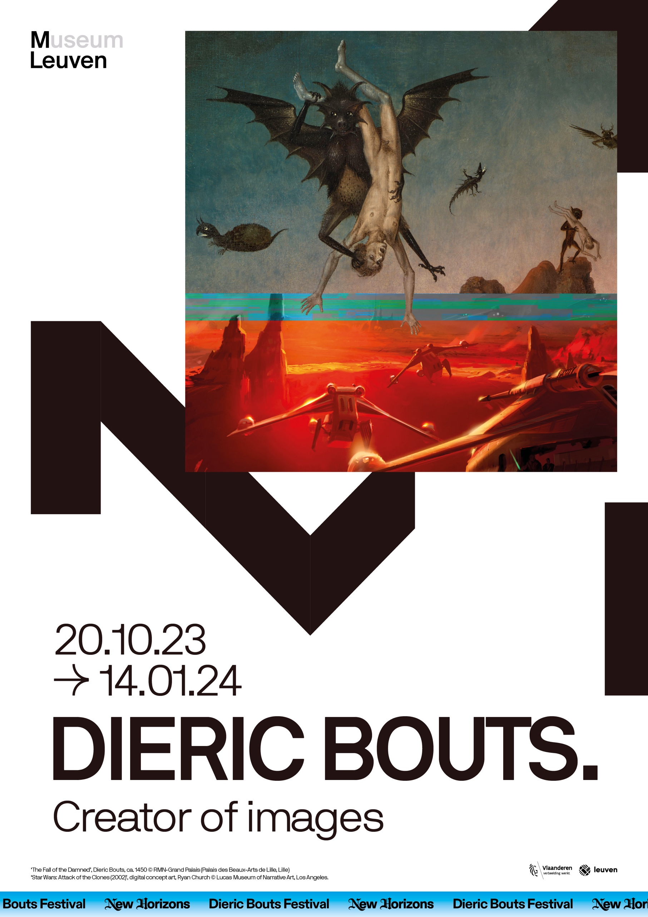

**CONTENTS**

Introduction – New Light on an Old Master 3

1. Leuven – The City that Stands Proud 4

2. Portrait – Not Made by Human Hands 5

3. Landscape – In a World far Away From Here9

4. Perspective – A New Window to Look Through11

5. The Mundane – The World is a Spectacle13

6. Finale – The Last Supper15

7. Jill Magid, ‘The Migration of the Wings’ 17

8. Opening weekend 18

9. Publications 20

**INTRODUCTION**New Light on an Old Master

M Leuven’s Bouts project is making Dieric Bouts part of art history. Never before have so many works by the Flemish master been brought together in his hometown. By radically confronting it with today’s visual culture, we bring a completely new perspective on work that is more than five centuries old.

Honours for a Forgotten Great

To this day, Dieric Bouts (c.1410-1475) has mainly been known as a ‘Flemish Primitive of the second generation’ or the ‘painter of silence’. His oeuvre is less well-known than that of pioneer Van Eyck and less *instagrammable* than Bosch’s apocalyptic scenes. This exhibition is an imposing tribute. For the first time, nearly 30 of Bouts’s works come together in Leuven, the city where he spent much of his life and where he painted his best panels.

‘Martyrdom of Saint Erasmus Triptych’, Dieric Bouts, ca. 1460-1464,

M Leuven / Saint Peter’s Church, photo: artinflanders.be, Dominique Provost

Fast Forward: Today’s Visual Culture

The concept of this exhibition is definitely radical: we are not allowed to look at Bouts as an artist. The image we have today of the *artiste peintre* did not exist in the 15th century. Dieric Bouts was not a romantic genius or brilliant inventor, he was an image-maker. He painted what was expected of him and excelled at it. So it makes sense to confront him with today’s image-makers: sports photographers, filmmakers, game developers. M Leuven places them side-by-side with the old master. We show their work, but also invite them to select: in whose work do they find Bouts’s technical magic tricks today?

**1. LEUVEN**

**The City that Stands Proud**

Dieric Bouts stood steady in the world, and that it the only way we can understand his work. Following the horrors of war and plague in the previous century, Leuven experienced a true renaissance in the 15th century. The new university allowed the Brabant city, in eternal competition with Brussels, to enjoy its days of glory. A new civic culture wrestled itself free from established values. The richness of Bouts’s scenes, the power of his portraits, his otherworldly landscapes: all are clarion calls that herald a promising future.

**Fast Forward: Convention is King**

Just as Bouts was inseparable from the city of Leuven, with its patrons, and religious and cultural trends, the image-makers of today are also shaped by the world around them. **Steven Degryse** is one such maker. Under the pseudonym Lectrr, he is active as a cartoonist, columnist and comic strip artist. With his daily cartoon for *De Standaard*, he takes a critical look at current events. Lectrr presents his work and reveals how he plays with visual conventions to steer the reading of an image or cartoon.

**Amira Daouidi** also works within the conventions of her time. A graphic designer who specialises in cinema, she created the posters for *Rebel*, *Gangsta* and *Rundskop*, amongst others. Using one of her own film posters, Amira zooms in on the constraints that clients impose on her during the creative process, and the artistic concessions that she must make.

Finally, ‘creative maker’ **Luc Shih’s** daily practice involves a combination of advertising work and designs for exhibition concepts, sets and prototypes. He confronts Bouts’s works with one of his own advertising campaigns. To convey his messages quickly and clearly, he needs to know his audience inside out, adapting to the medium the viewer ‘uses’.

‘Study of a Kneeling Man’, (workshop) Dieric Bouts, ca. 1475-1499 © Rijksmuseum, Amsterdam (Purchase from the F.G. Waller Fund)

**2. PORTRAIT**Not Made by Human Hands

Leuven in the 15th century was brimming with self-confidence. The result are a glorious new city hall, St Peter’s Church, and, of course, the university, all big investments made by a proud city. But visual culture also changed and paintings previously reserved for the aristocracy and the church seeped through to a wider layer of the population.  
  
Neither the kings nor the popes could offer an answer to the ravages of the 14th century. Neither penance nor donations to the church helped against the plague. People sought new answers and no longer relied on existing power to provide them. Modern Devotion gained success in the Low Countries: a movement that launched the startling idea that we could also take our destiny into our own hands.

The Paperbacks of the 15th Century

It was university professor Henri Wellens who kicked off Modern Devotion in Leuven.   
He donated the priory of St Martin to the Brethren of Common Life in 1435. That grew into a production house where manuscripts were copied en masse, in a standard format and without illustrations. Very different, in other words, from the richly illuminated manuscripts in the dukes’ libraries.

Those manuscripts were hardly paperbacks but it was quantity that counted. Thomas a Kempis’s *The Imitatio Christi* was copied particularly frequently. The book was a manual for individual soul salvation with concrete tips for a wide audience on community work and personal success following the example of Christ. The practices of the Brethren of Common Life were borderline heretic but they escaped persecution thanks to their modest profile.

An Icon for Everyone

There was also a new and flourishing market for devotional pictures among wealthy citizens, in particular for portraits of Christ and Mary. What was special about this was that these portraits possessed a high spiritual charge, a divine ‘energy’. They counted not simply as *images* of the divine, but as divine *in their own right*. Like a relic of a saint, but no longer exclusively reserved for the church as the case had been in the past.

Two such portraits are Bouts’s *The Man of Sorrows* or *The Face of Christ*. They refer to Veronica’s sudarium. She used a piece of cloth to dry Jesus’ face as he was on his way to his death on the cross, leaving an imprint of his face on the cloth. The result was a ‘painting’ that was not made by human hands. That, in turn, created an endless series of copies with the same divine power. Those who brought a ‘vera icon’ (almost an anagram of Veronica) like this into their homes literally brought God into their homes.  
  
‘The Man of Sorrows’, Dieric Bouts, ca. 1470, M Leuven, photo: artinflanders.be, Cedric Verhelst

Something similar was true for the portraits of Mary.   
The underlying idea there was that she had been portrayed with her child by the evangelist St Luke. Countless copies and variants were made of the famous *Madonna of Cambrai*, which in the 15th century was still assumed to be the original portrait. Bouts’s portraits also bore the quality label of being more than just an image. Each Madonna with child referred to that one moment when she posed before St Luke, and then also in the presence of God himself, as a baby on her arm.

‘Virgin and Child’, Dieric Bouts (follower of), ca. 1465   
© Museo Nacional Thyssen-Bornemisza, Madrid

Fast forward:   
From Flemish Masters to Top Athletes

In the 15th century, it was popular to paint the face of Christ. It was a devotional image that proved how deeply Christ had suffered for mankind. The intention, in the best tradition of the Modern Devotion, was for the spectator to share in that suffering. This is exactly how sports photographers portray athletes today. We stand in silent adoration of their epic performances, the supernatural physical exertion, the foregoing. But in the end, the winner, arms wide, rides across the finish line like a hero. The suffering was great, but the victory total.

Two professional photographers show us how Eddy Merckx appeared on the front pages after yet another endurance test ended in victory. His look – between suffering and triumph – resembles that of Christ in the devotional portraits that Bouts produced on the conveyor belt.

**Jasper Jacobs** is a freelance sports photographer, working to assignment for several newspapers and specialised magazines. Amongst other things, he photographs the Jupiler Pro League football matches, as well as the Europa and Champions League, cycling races and athletics meetings.

**Sebastian Steveniers** works as a freelance documentary photographer for *De Standaard* and is best known for his series *Bosfights/Live Free*, in which he documented the secret and illegal fights between football hooligans.

A Madonna for Every Age

Just as the (Italo-)Byzantine pictorial tradition inspired Bouts when painting his portraits of Mary, medieval religious iconography continues to inspire contemporary image-makers. The Mother of God is exalted and heavenly but also a woman of flesh and blood: it is an iconic image amongst contemporary documentary, fashion and pop photographers. Female idols often acquire a ‘holy’ status – think Beyoncé or Lana Del Rey, with their hundreds of thousands of followers. But Marian portraits inspire much more: each woman’s humanity, her bond with her child, her occasional vulnerability, her unconditional love.

Photographer and film-maker **Charlotte Abramow** and stylist and fashion consultant **Tom Eerebout** – both at home in the world and its visual language – have curated a selection of contemporary fashion photographs and celebrity portraits, in which the tradition of the Madonna portrait is not far away. At a young age, Abramow started working as a photographer for magazines and young brands; not much later, she also made her international breakthrough after her collaboration with the singer Angèle, including for the *Balance ton quoi* music video. Eerebout works with Lady Gaga, Kylie Minogue, Rita Ora and Austin Butler, amongst other clients. He provides clothes and looks for photo shoots, red carpets, tours and music videos.

**3. LANDSCAPE**In a World Far Away From Here

A tree, a rock, a meandering river: in the Middle Ages, these were nothing more than decorative elements to illustrate the setting of the story, sometimes literally to fill the corners of a miniature. That changes in the 15th century. In the new bourgeois culture, a penchant for realistic landscapes that create a different world is emerging.  
  
Dieric Bouts certainly did not invent landscape painting. There are wonderful examples of landscapes in the oeuvres of Jan van Eyck and Rogier Van der Weyden. But Bouts definitely takes it a step further. He perfects the visual techniques and brings depth to a landscape, techniques that will also continue to spread in the rest of Europe and which for centuries to come will be among the basic skills of any classically trained painter.

‘Ecce Agnus Dei’, Dieric Bouts (follower of), 1500 - 1520 © Staatliche Museen zu Berlin / Gemäldegalerie, Berlin, photo: Christoph Schmidt

Revolutionary Depth

Bouts starts with the *repoussoir* effect where he places a character, bush or stone in the foreground to create believable depth, layer after layer. Characters and landscape elements no longer stand together in a ‘cluster’ but are instead staggered. He then applies atmospheric perspective: a landscape on the horizon (in *The Pearl of Brabant,* for example) surrounded by a blue haze or light mist that makes it seem to lie at a credible distance.

Third, to connect all the layers, he uses eye-leading elements where a road or river brings the viewer into the background. The viewer goes on a journey through the painting. When standing in front of a panel by Bouts today, we stand in admiration of the simple construction of his setting, but for the people of Leuven at the time, it must have been a visual sensation. Compare it to the pioneering days of cinema: rumour has it that spectators jumped backwards when they saw a train approaching on the screen. The reaction to Bouts’s realistic landscapes would also have been astonishment.

Travelling to Somewhere You Can Never Be

Note: the world Bouts so realistically creates is not ours. Dramatic rock formations and exotic plants were not part of the Flemish landscape anymore back then than they are now. To see anything like it, an onlooker would have had to travel to, say, Dinant or, when for some of the plants or the unusual architecture, to the Middle East. Some did of course also then, there had already been several crusades, but for the average viewer, the universe Bouts created was definitely a different world.

In doing so, he appealed to new emotions that will surely have pleased the emerging urban elite. These were people who wanted to dream, or shudder. That the two were close is proven by a diptych like *Paradise and Hell*. Did this serve a theological purpose, to beat and anoint the viewer at the same time? Most certainly. Did he cater to the typically human appetite for fantastic images and dream worlds? Very much so.

Fast forward: In a Galaxy Far, Far Away…

Dieric Bouts was a pioneer of the landscape. In doing so, he sought the tension between realism (creating depth as realistically as possible) and fantasy (this is a world that is not ours). Science fiction came out of the same friction. It’s all so real, it’s all so strange. A brilliant example is the universe George Lucas created in *Star Wars*. His characters are tangible and even the alien life is flesh and blood, with emotions like ours. But the costumes, sets and fantastic storytelling leave no doubt: this is a world far, far away. The original storyboards from the *Star Wars* films will be shown alongside Bouts’s works during the exhibition. This is thanks to a special collaboration between M and the **Lucas Museum of Narrative Art**, George Lucas’s museum of narrative art and storytelling that will open its doors in Los Angeles in 2025.

**4. PERSPECTIVE**A New Window to Look Through

The founding of Leuven University in 1425 put the city on the European map. The most innovative ideas from Germany and Italy quickly found their way here too, including the new theories on perspective in painting. Dieric Bouts was one of the first to see this.  
  
If Bouts has made it into art history textbooks, that had a lot to do with his application of the vanishing point perspective. In summary, all the lines in a two-dimensional work converge into a single point, creating a believable illusion of depth. Bouts was not the first to use this perspective, but he was among the pioneers, along with, for example, Piero della Francesca in Italy.

‘Virgin and Child with four angels’, Dieric Bouts, before 1469 © Capilla Real, Granada, photo: Armando Bernabeu Granados

In God, All Lines Converge

Today, with our oversaturated eyes used to thousands of pictures a day we hardly notice this innovation, but for 15th-century viewers it must have been amazing. The German philosopher Cusanus attached a theological idea to it, the imaginary point where everything came together was God. This immediately gives the frame around the painting another meaning. Behind this ‘window’, there is not only a third dimension to discover but a divine one too.

We know that Cusanus twice was asked to become a professor in Leuven, a city that was then a magnet for new ideas. It is therefore perfectly possible that Bouts had heard of his theory. If so, his painterly feat served not only to create the illusion of reality, but just as much for the spiritual dimension: we are all travelling to the same point.

Fast forward: The Game of Reality

One of the greatest innovations of the Renaissance was the development of mathematical perspective. Bouts was part of the avant-garde at the time. The impact of the discovery has had a lasting impact on our visual culture (until Picasso shook things up again). Every picture and every film uses this perspective naturally, because it is how nature works. One domain where there was no need to redevelop this ‘window on the world’ was the gaming industry. From Wolfenstein-3D to the latest Grand Theft Auto, all the lines once more converge behind the computer screen. The advance of Virtual Reality (VR) presents new challenges for game developers: perspective manipulation must ensure recognisability in this immersive mock world.

**Adalberto Simeone** is a professor at KU Leuven’s Department of Computer Science, specialising in 3D interaction and virtual reality. For M, he zooms in on the different ways that perspective is used in video games to create realistic, digital worlds.

**5. THE EVERYDAY**The World is a Spectacle

The utterly new use of depth in the Renaissance, both thanks to landscapes and the vantage point perspective, opens up an entire world of possibilities. For the first time, a stage emerges behind the frame of the painting, a scene that can be filled with characters, objects, interiors, in fact with anything. What does Dieric Bouts choose to do?  
  
‘Triptych of the Deposition’, Dieric Bouts, ca. 1450-1458 © Capilla Real, Granada, photo: Armando Bernabeu Granados

Art historians such as Erwin Panofsky have long set the tone for the interpretation of Flemish masters. He read almost every element in every painting as a symbol. The dog at the feet of Van Eyck’s Arnolfinis is a symbol of fidelity, a lily behind Mary is a symbol of her virginity, a palm tree represents Heavenly Jerusalem. That symbolic reading usually makes sense as proven by the countless other dogs, lilies and palm trees used by other masters in the same context.

Sometimes a Bread-Roll is Just a Bread-Roll

But perhaps there are limits to the theory of ‘disguised symbolism’. For example, how do you interpret the sheet hanging over the edge of the table on Bouts’s *Last Supper*? Is it a foreshadowing of the shroud in which Christ will be wrapped the day after? Or is it just a tablecloth in a beautifully painted drapery? Are the knives on the table a harbinger of the tortures that await Christ? Or are they just for cutting the sandwiches in half?

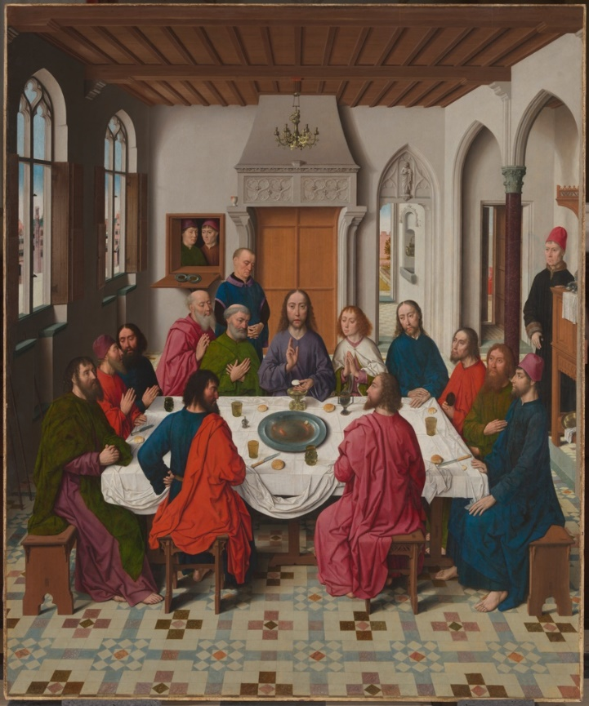  
‘The Last Supper’, Dieric Bouts, 1464-1468,

M Leuven / Saint Peter’s Church, photo: artinflanders.be, Dominique Provost

Sometimes it is what it is. The method of symbolic reading has become so ingrained that we are in danger of falling into the trap of interpreting every glass and decorative element as something else. Theologians helped shape Bouts’s world and many of his set pieces indeed contain a double meaning. But looking at him through a different lens brings a breath of fresh air. The painter who depicts objects and customs as they appeared in his time, simply to create a (for them) contemporary atmosphere.

Fast Forward: A Bridge Between Past and Present

Bouts heightens the sense of reality in his work by using ‘real’ elements. With objects and situations that were familiar to 15th-century viewers, but are just as recognisable today, he builds a bridge across time. Averse to drama and pathos, he uses ordinary life to capture nuances that are just as relevant to today’s viewers, precisely because they are so recognisable.

Film director **Pier Paolo Pasolini** did the same thing, but took a slightly different approach. In his film *Il Vangelo secondo Matteo*, he tells the Gospel according to Matthew in a way that makes it ‘down to earth’ and of ‘the people’, thereby divorcing it from ecclesiastical morality or 18th-century heroism. He uses non-actors, makes them speak in dialect and chooses recognisable locations. At the same time, he does not add a single word to the original text. He stays true to the scripture, literally following it to the letter. In so doing, he also builds a bridge: a 15th-century visitor, without any knowledge of cinema, would understand everything about this film.

Cinematographer **Gust Van den Berghe** recognised Bouts’s sense of realism in Pasolini’s *Il Vangelo secondo Matteo* and has curated a series of excerpts. Van den Berghe is known for the feature films *Little Baby Jesus of Flandr, Blue Bird* and *Lucifer*. His films have already been screened – and won awards – at the Cannes Festival, the Flanders International Film Festival (Film Fest Gent) and the Athens International Film Festival.

**6. FINALE**The Last Supper

The ‘grand finale’ of the exhibition is *The Last Supper* by Dieric Bouts. People from Leuven know it from St Peter’s Church, the church for which the altarpiece was also originally painted. For this exhibition, Bouts’s magnum opus will temporarily move to M Leuven. This is indeed the pinnacle, the work in which all the previous lines come together.

‘Last Supper Triptych’, Dieric Bouts, 1464-1468,

M Leuven / Saint Peter’s Church, photo: artinflanders.be, Dominique Provost

Modern Devotion and the New Portraiture

You don’t have to be an expert on the Bible to see that the middle panel of *The Last Supper* has too many characters. The additional extras, besides Jesus and the 12 apostles, are presumably the patrons of the painting: the League of the Blessed Sacrament. They certainly took all their inspiration from Modern Devotion. They stood for an individual quest for soul salvation, averse to established power and helped promote the spread of ‘animated’ Christ and Mary portraits.

Landscape and Perspective

The side panels prove just how far ahead Dieric Bouts’s landscape painting was. There are scenes from the Old Testament that refer to food and the sacrifice Christ would later make.   
The *March Through the Desert* panel uses all the techniques of depth effect: *repoussoir,* atmospheric perspective, the walkway as an eye-catching element. But what perhaps struck viewers most was the dramatic effect of the opening in the clouds, where God appears as the end point of each journey.

The Everyday Scene

The altarpiece was intended for the sacramental chapel of St Peter’s Church. By the way, a vista of the Grote Markt can be seen from the pointed arches of the windows, left on the central panel. Rather than the Easter lamb, Bouts paints an empty dish with a brown meat gravy. There are no chalices, but contemporary glasses. So the whole setting of the set table feels curiously homely. We are not looking at Jerusalem in the year 33, we are looking at Leuven in 1465. The Leuven of Dieric Bouts.

**7. JILL MAGID, ‘THE MIGRATION OF THE WINGS’**Leuven’s St Peter’s  
20.10.2023 – 14.01.2024

In autumn 2023, M Leuven is organising a special in-situ presentation in Leuven’s St Peter’s Church. It will revolve around ‘The Migration of the Wings’, a film and sound installation by American conceptual artist, writer and filmmaker Jill Magid. The installation will use *the Holy Sacrament triptych* (1464-8) by Dieric Bouts, commissioned for St Peter’s Church, to activate the church building as a musical instrument. This will build on a variation of this installation shown at M during Magid’s solo exhibition this upcoming spring.

‘The Migration of the Wings’ follows the movements of the *Holy Sacrament triptych*, which was dismembered in 1707, when the central panel was stripped of its wings. In modern history, the outer panels have been treated, both legally and by force, as reparations of war between Germany and Belgium. Through sound, image, and sculpture, themes of exile and diaspora, war and repatriation, and the resonance of violence echo throughout the church.

Curator: Valerie Verhack

Jill Magid, ‘The Migration of The Wings’, two-channel digital video, sound (in progress), film still, 2023

**8. OPENING WEEKEND**

M Leuven   
20.10 – 21.10.2023

# The opening weekend of *Dieric Bouts. Creator of Images* at M will be filled with guided tours, performances and various activities for young and old. The Bouts radio play and family trail will have their premiere during the day, while everyone is welcome to attend the evening preview when young artists will confront Bouts.

PREVIEW WITH PERFORMANCES, MUSIC AND INSTALLATIONS FOR ‘DIERIC BOUTS’.

21.10.2023

# The young art and music collective Veduta invites you to discover the exhibition on the first evening of the grand opening weekend, complemented by performances, live music and installations. Grab a drink at the bar and discover how the historical and contemporary go hand in hand.

[Register](https://www.mleuven.be/programma/vernissage-bouts)

RADIO PLAY FOR FAMILIES AROUND ‘DIERIC BOUTS’.

21.10.2023

Even though Dieric Bouts was one of the most important Flemish Masters, he is sometimes overlooked. Especially for the major Bouts exhibition, Warre Borgmans – at long last! – reveals Dieric’s wonderful story. During the opening weekend, Het Geluidshuis will premiere the Bouts radio play. Families with children aged 8 and over can settle into one of M’s cosy corners and find out just who Dieric Bouts was – and why we should never forget him (only in Dutch).

[Register](https://www.mleuven.be/programma/hoorspel-voor-families-dieric-bouts)

GUIDED FAMILY TOUR OF ‘DIERIC BOUTS’.

21.10.2023

On Saturday 21 October, during the exhibition’s opening weekend, a guide will show families with children up to 12 years old how Dieric Bouts’ visual tricks still crop up in today’s visual culture. A grand tour, tailored to young and old alike (only in Dutch).

[Register](https://www.mleuven.be/programma/familierondleiding-dieric-bouts)

CHILDREN’s AUDIO TOUR FOR ‘DIERIC BOUTS’.

21.10.2023 - 14.10.2023

On Saturday 21 October, during the opening weekend, children aged 8 to 12 can be the first to try the Bouts audio tour. This way, they will discover the juiciest stories and most fascinating facts during their visit to the exhibition. All they have to do is stop at the audio symbols they encounter. Tell them to listen carefully – they won’t believe their ears! (only in Dutch)

[Register](https://www.mleuven.be/programma/audiotour-kinderen-dieric-bouts)

FAMILY TRAIL ‘DIERIC BOUTS’.

21.10.2023 - 21.10.2024

Visiting the great Dieric Bouts exhibition with kids? Good idea! With this family trail, families with children aged 4 to 6 can discover Dieric Bouts’s masterpieces in a playful way and at their own pace. Especially for young sleuths and clue-hunters, there is a fun search booklet with stickers (only in Dutch).

[Register](https://www.mleuven.be/programma/familieparcours-dieric-bouts)

**9. PUBLICATIONS**

**DIERIC BOUTS. CREATOR OF IMAGES**

[Hannibal Books](https://hannibalbooks.be/?gclid=Cj0KCQjw7uSkBhDGARIsAMCZNJsknHBKppcY-tNx5SJQ_w-wAXtCCwM0eoi6bxtpt2T9YAq05K-mNoMaAsuiEALw_wcB)

Dieric Bouts (c. 1410 - 1475) is one of the most elusive figures in the history of Western art. Flemish primitive of the second generation, painter of silence – these are the labels he is usually given. But surely there is more to the Brabant master than this?

This book, published on the occasion of the exhibition *DIERIC BOUTS. Creator of Images* (20 October 2023 to 14 January 2024) at M Leuven, endeavours to get closer to this enigmatic figure. Dieric Bouts was grounded in his world; this is the only way we can understand his work. Essays on the Flemish Master’s significance and shorter focus texts on individual works will together outline the social, intellectual and artistic context in which Bouts lived. They illuminate his oeuvre from new angles and offer a fresh perspective on works that are over five centuries old, most notably through a radical confrontation with today’s visual culture. The result is a more nuanced picture of the great Leuven artist: Bouts recaptures his place in art history as the eye-opening creator of images that he truly was.

Publisher: Hannibal Books

Final editing: Peter Carpreau

With contributions by: Mark Derez, Michiel Verweij, Stephan Kemperdick, Inigo Bocken, Valentine Henderiks, Didier Martens, Till-Holger Borchert, Peter Carpreau, Gust Van den Berghe, Jordan Marie Booker, Marjan Debaene and Bart Fransen.

Languages: Dutch, English, German

Number of pages: 224 p.

Price: € 49.95

**DIERIC BOUTS**

[Special edition OKV](https://www.okv.be/)

Languages: Dutch, French

Total pages: 40 p.

Price: € 12

**FOR THREE MONTHS, LEUVEN   
EXPLORES NEW HORIZONS**in a dynamic cultural city festival   
dedicated to Dieric Bouts

From October 2023 through January 2024, Leuven sets the stage for a large, dynamic cultural city festival. Dieric Bouts is the festival hero, the 15th-century artist who painted his most important works in Leuven. What makes this festival so special? Dieric Bouts was an innovator, always eager to explore new horizons. That made him an inspiration to many in his day, and it still will in 2023.

Join the Leuven City Festival in 2023 to discover and explore dozens of new horizons, from art and music to theatre and lectures. M Leuven’s Bouts exhibition is bound to be a major crowd-puller. Over 30 works by the Flemish Master instantly make it the largest collection to ever be exhibited under a single roof. And with loads of other events for all ages, the city festival will inspire and excite local and foreign visitors with infinitely more than visual art.

Bouts’s insatiably explorational and inquisitive spirit is around every bend! Unsurprisingly, EventFlanders singled the city festival out as a 2023 Top Event.

Dieric Bouts, new perspective in 2023

Bouts’s works are on display at top museums at home and abroad. Two of his masterworks remain in Leuven’s St Peter’s Church, where Bouts was commissioned to paint them – his magnum opus, *The Last Supper,* and *The Martyrdom of Saint Erasmus*.

But there’s another reason that Bouts deserves to play the lead in Leuven’s city festival. The mentality that distinguishes Leuven and its university is fully in keeping with the person of Bouts, i.e. that inquisitive, innovative, open, and curious mind. Dieric Bouts’s futuristic outlook continues to inspire. What better response than a city festival that illuminates new horizons from cultural, artistic, historical, and contemporary perspectives?

For those ready and willing to explore and discover, three months of astonishment await, starting October 2023.

The city festival is a KU[N]ST Leuven event in partnership with the city of Leuven and KU Leuven and as an M Leuven collaboration.

**FLANDERS FUNDS LEUVEN’S INTERNATIONAL WORLD-CLASS DIERIC BOUTS EVENT (2023)**

Come autumn 2023, Leuven will host a major cultural city festival starring Dieric Bouts. Leuven’s new City Festival sets out to discover traces left by the ingenious 15th-century painter Dieric Bouts...how he inspired in his time and continues to fire the imagination in 2023. The festival’s highlight will be M Leuven’s international loan exhibition, featuring nearly thirty original works by the painter. Never have so many of Bouts’s pieces been displayed in a single location. This ambitious, innovative project aims to put Bouts and Leuven on the international map. And with two million euros in funding, Flanders helps make that happen.

Leuven’s 2023 City Festival is a KU[N]ST Leuven event in partnership with the city of Leuven and KU Leuven and as an M Leuven collaboration.

New perspectives on forgotten genius

Dieric Bouts is a lesser-known figure in public memory. But international experts recognise his tremendous impact and art-historical significance. Consequently, his works can be seen on display at top museums at home and abroad. Two of his masterworks remain in Leuven’s St Peter’s Church, where Bouts was commissioned to paint them – his magnum opus, *The Last Supper*, and *The Martyrdom of Saint Erasmus*. Both festival and exhibition rightly put Bouts front and centre, giving him the recognition he deserves.

This endeavour aims to explore new horizons in relation to Bouts and contextualise his work within the early Renaissance and nascent humanism of the 15th century. Simultaneously, the lasting relevance of Bouts’s innovative work is revealed by seeking parallels with our own contemporary visual culture and society.

Flemish Minister-President and Minister of Culture Jan Jambon: ‘*The Flemish Community is proud to partner on this ambitious, innovative project that puts Bouts on the international map as a Flemish Master and grants him a new place in art history.*’ Zuhal Demir, Flemish Minister of Tourism, adds: *‘Since the Middle Ages, the Flemish Masters and their craftsmanship, creativity, and technical ingenuity have captivated the world’s admiration. Bouts is a perfect addition to the ranks of Flemish Masters who helped shape European art history and continue to inspire to this day.*’

Mayor of Leuven, Mohamed Ridouani: ‘*Internationally speaking, Leuven has always been at the forefront of science and knowledge. Bouts seamlessly fits within that narrative as a pioneer, innovator, and explorer of new horizons. By viewing him through our 21st-century lens, we prove that Bouts is more relevant than ever, that he continues to inspire*.’

Bert Cornillie, Deputy Mayor of Culture and Chair of M Leuven, sketches the broad outlines of the city festival: ‘*For three months, we will highlight this extraordinary Leuven citizen from every possible cultural, artistic, historical, and contemporary angle. The heart will be the M Leuven exhibition. Never before have so many original works by this Flemish Master been assembled in his hometown. This remarkable achievement is the result of years spent by M Leuven’s team in negotiations. The exhibition’s transhistorical approach is sure to enthral young and old alike.*’

The M Leuven exhibition is part of a broader festival programme, which coalesced through the dynamic collaboration of Leuven’s cultural, scientific, and tourism partners. Bart Raymaekers, Adviser to the Rector for Culture, Art and Heritage at KU Leuven: ‘*The mindset that distinguishes our university is fully in keeping with the person of Dieric Bouts, i.e. that inquisitive, innovative, open, and curious outlook. For those ready and willing to explore and discover, three months of astonishment await, starting October 2023*’.

The M Leuven exhibition runs from 20 October 2023 through 14 January 2024.   
Curator: Dr Peter Carpreau.

The Flemish Government has classified Leuven’s 2023 City Festival as a world-class event. EventFlanders funds have been earmarked as support. EventFlanders is a partnership between Toerisme Vlaanderen, the Department of Culture, Youth, and Media, Sport Flanders, and the Department of Chancellery and Foreign Affairs.

PRACTICAL

M LEUVEN  
Vanderkelenstraat 28  
3000 Leuven  
+32 (16) 27 29 29  
[info@mleuven.be](mailto:info@mleuven.be)  
[www.mleuven.be](http://www.mleuven.be)

Plan your route to the museum

By bike  
Cyclists are welcome! Parking is easy. Just use the secure underground bicycle parking at Rector de Somerplein. From there, it’s just a two-minute walk to the museum.

Via public transport  
The museum is a ten-minute walk from Leuven Station. Rector de Somerplein is the closest stop if you’re coming by bus. Use Google Maps to plan your route.

By car  
Leuven’s new circulation plan leads you into the city and car parks via a series of rings. Would you prefer to avoid the city’s traffic? Just park your car at one of the car parks on Leuven’s outskirts and catch a free bus to the centre. Prefer to park nearby? The Ladeuze car park is only a two-minute walk from the museum. There are also 18 spaces for disabled passengers (higher clearance: 1.90 m). Click here for more information on the circulation plan and parking options.

CONTACT

Hanne Grégoire  
Head of Press & Communications  
[hanne.gregoire@mleuven.be](mailto:hanne.gregoire@mleuven.be)  
+32 (0)472 95 52 26

Samantha Fadahunsi  
Press & Communications Officer  
[samantha.fadahunsi@mleuven.be](mailto:samantha.fadahunsi@mleuven.be)  
+32 (0) 491 35 02 95

Celine De Geest  
Press & Communications Officer  
[celine.degeest@mleuven.be](mailto:celine.degeest@mleuven.be)  
+32 (0) 479 67 65 31

Web page links:  
www.mleuven.be/en/programme/dieric-bouts